Name: ________________

ECE 101 LAB 1 a, b & c: OHMS LAW, SERIES AND PARALLEL CIRCUITS & SENSORS

- Overview
Welcome to the ECE 101 lab! In this lab you will learn more about DC circuits, various resistors and how resistors are used in circuits. You will also develop some basic lab-bench skills. You are encouraged not to stop at just filling in the blanks but to explore these topics on your own.
  - Pre-lab assignment
Watch video on protoboard use https://www.youtube.com/watch?v=oiqNaSPTI7w . Second part of it is here https://www.youtube.com/watch?v=Mq9XMNsoAd8 and is optional. It has some useful additional information but you are not expected to build the circuit presented there. Another similar video is here https://www.youtube.com/watch?v=k9jcHB9tWko . Find and read some online materials on photoresistors and thermistors.
  - Laboratory Objectives
This handout contains a 3-part lab; the plan is to spend two weeks on it. If you finish early, go on to the next section. If it takes you longer, don’t worry about it. Take your time, work at your own pace and be sure to answer all the questions and to understand each step. There are two main objectives:
- familiarize yourself with the lab equipment
- put to use math concepts of linear and quadratic equations to use
Fill in the results and answer the questions right on this handout. You can turn it in online using the D2L Dropbox. You have up to one week after completing the lab to turn it in – check out the deadlines listed on D2L. Everyone needs to turn in an individual report.
  - Notes:
- Some items are labeled “Later” which indicates that you can finish these items after the lab session is over. Performing measurements and collecting data is the first priority so do them first because they have to be finished during the lab session. Typically, the “later” items are some calculations based on measured data, MATLAB plots and discussion items.
- Some items have checkbox next to them – this indicates that TA will be checking that you completed this item.
- Some discussion items ask you to enter some text – please do this using Word and then submit the whole file on D2L. If you absolutely, positively cannot do this please contact your TA for different arrangements.

- Part I. Ohm’s Law
  - Objectives:
- Learn to use a DC power supply, multimeter and protoboard
- Verify Ohm’s law

  - Equipment:
Lab bench DC power supply, multimeter and computer, ECE 101 lab kit with protoboard, wires, cables and assorted resistors (ideally 220, 1k, 2k and 47 kOhm, but actual may vary; remember 1 kOhm = 1000 Ohm)
  - Background:
OHM’S LAW defines the relationship between voltage (V), current (I) and resistance (R) in a resistor:
$$I=\frac{V}{R}= \frac{1}{R}V or V=IR$$
i.e., the current through a resistor is directly proportional to the voltage across the resistor and inversely proportional to the resistance. Typically, we will view I and V as variables (dependent or independent) and R (or 1/R) as proportionality constant between the two.
Important information before you begin:
Find the Quick Guides on the lab web page (http://web.cecs.pdx.edu/~ecelab) for the Protoboard (also called a breadboard), DC Power Supply (“PS”) and Multimeter (“MM”). I suggest you have them open on the computer during the lab for reference. This handout will only provide general instructions, while the guides have detailed instructions for the specific equipment in the lab. Not every bench has the same model; make sure you reference the correct guide. If in doubt please ask the TA for help!
We will be using the MM to measure resistance, voltage and current. Be careful that you have the MM connected correctly and set correctly for the three kinds of measurements! It is very easy to blow the fuse in the MM (and in the lab manager ) if this is not done right, and the fuses are expensive. Refer to the MM quick guide, and if you have any doubts, ask the TAs.
- For resistance and voltage measurements, place the MM leads across the component, and set the MM for Ohm or DC voltage, respectively. In Figure 1a (next page,) the MM-box represents the placement of a meter to measure the voltage across R. To measure resistance, you do not have to put the resistor in the protoboard at all, just connect the meter to the resistor alone. Placing a resistor in protoboard may make the connection easier to make – see what works for you the best.
- For current measurements, place the MM in series with the component, and set the MM for DC current. In Figure 1b, the MM-box represents the placement of a meter to measure the current through R. Where multiple ranges are available, start with the highest to be safe and then turn it down as needed. Use the lowest possible range to get the best resolution.

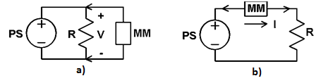
Figure 1. a) Using multimeter (MM) to measure voltage, and b) Using MM to measure current.

  - Lab assignments
    - Simple resistance measurements using MM as ohmmeter
- Find a nominal 1 kOhm resistor by measuring resistance with the MM. Verify color code if desired. If you do not have a 1 kOhm resistor, use another value, but change the table below to reflect what you actually used. Record the actual measured value here,

- R = _____________________________

- Calculate I for each V in the table below, and record the calculated value in mA (1 mA = 0.001 A). Use the measured value of R.

    - Resistance measurement using Ohm’s law
- Build the circuit in Figure 1b on your protoboard. Do not turn on the PS until you have set up and carefully checked your circuit. Refer to the protoboard guide to see how the rows and columns are connected. There are convenient sockets to connect to the PS, but these are not automatically connected to the rest of the board. It’s useful to connect the sockets to the “vertical” lines (the long colored lines) with jumper wires, then you can easily connect from there to other components, as shown here:

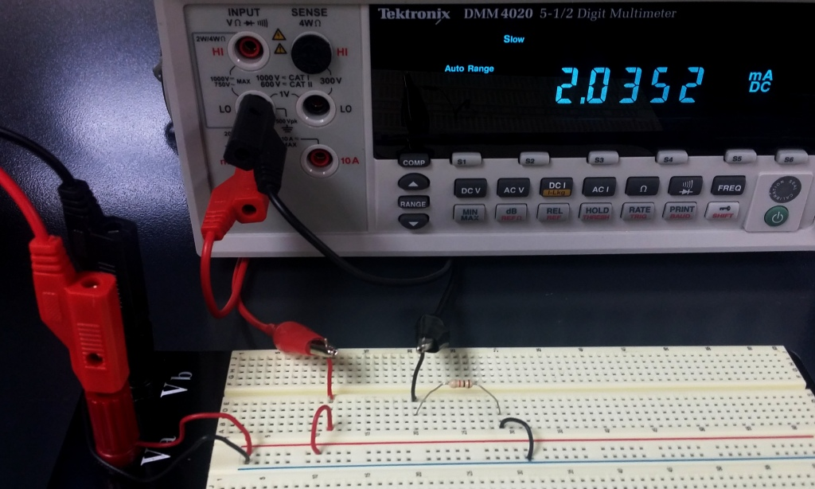
Figure 2. Proper wiring on protoboard; MM is used as ammeter.

- Set the PS to each voltage in the table and measure I.
- Fill in measured and calculated values in Table 1.
Table 1. Calculated vs. measured currents using Ohm's law.
V (Volts) | R_{meas} (Ohms) | I_{calc} (mA) | I_{meas} (mA)
0 | 1k (nominal)
0.5 | 1k
1.0 | 1k
1.5 | 1k
2.0 | 1k
2.5 | 1k

- Do the calculated and measured values agree? They should be very close, so if they are not you should double-check what you are doing or ask for help.

__________________________________

    - Resistance measurements – part 2
- With V constant at 5 V, change the resistor and observe the change in I. Record the calculated and measured currents for each resistor in the table below. Again, if you do not have the resistors listed, just use what you have and write down what you actually used. Be sure to have some larger and some smaller values so you can see the difference. Use the actual measured value of R to calculate I.

- Fill in Table 2
Table 2. Calculated vs. measured currents using Ohm's law for different resistances.
V (Volts) | R_{meas} (Ohms) | I_{calc} (mA) | I_{meas} (mA)
5 | 220 (nominal)
5 | 1k
5 | 2k
5 | 47k

    - KVL and resistance combined
- The value of the resistor in Figure 3 below is unknown. Construct the circuit and use the laboratory equipment to find this value. Complete Table 3 and record the current value measured on the ammeter. You need to be careful how you connect the two sources together – see Figure 3 below for schematic and Figure 4 for voltage source connection. Wait for the TA to verify your circuit.
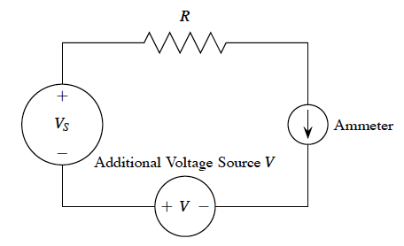
Figure 3 Circuit for illustrating KVL and resistance calculation.
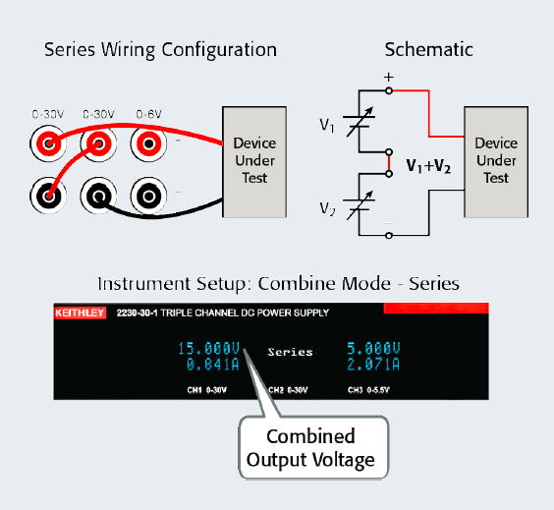
Figure 4. Voltage source with 2 channels connected in series.

- Fill in Table 3
Table 3. Two voltage sources in series: KVL and calculating resistance.
Voltage Vs (Volts) | Add. Voltage V (Volts) | I_{meas} (mA) | Measured R (Ohms)
0 | 5
5 | 5
7 | 5
9 | 5

- Calculate the resistance R in the last column using Ohm’s Law. (Pay close attention to UNITS!)

$$R=\frac{V_{S}+V}{I}$$

- (Later) Plot Vs (y-axis) vs. I (x-axis) in MATLAB using this syntax:

x=[]; This command defines a row vector x. Place real numbers within the square brackets separated by spaces or commas. Do the same for y values. Semicolon at the end suppresses display of variable – try the command with and without it.
plot(x,y,’o’) This command plots the data in vectors x and y and does not connect lines between each point.
- Save the graph in png format using this command (for jpeg use “jpeg” instead of “png”):
print –dpng myplot (where “myplot” is filename)

By default MATLAB stores these files in your local directory (check where this is typically located).

Insert your MATLAB plot here (use drag-and-drop or the “insert” menu in Word).

- From this plot estimate the value of R, slope of the curve and y-intercept point:

slope = _______________ y-intercept= _____________

- To what component of circuit does the y-intercept of this plot correspond?

____________________________________

- EXTRA: Using MATLAB’s Basic Fitting tool, find the slope and y-intercept of the graph.
- EXTRA: Find out ways to improve your plot (e.g. add axis, title etc).

- (Later) Discussion of results and reflection:

- Did your experimental results agree with Ohm’s Law?

- Did your measurements and calculations agree?

- Speculate why they would not agree exactly.

- Do you have any further observations or comments on this part of the lab? Please reflect on your learning experience – what helped your learning and what detracted from it.

- Part II. Sensors: Photo- and Thermal Resistors
  - Objectives:
To observe variation in resistance and current with
- varying light intensity in a photo-resistor
- varying temperature in a thermistor

  - Equipment:
Same as Part I plus a photoresistor and a thermistor
  - Background:
A photoresistor is simply a resistor made of a material, often cadmium sulphide, whose resistance changes with light intensity. Similarly, a thermistor is a resistor made of a material, typically a ceramic or polymer, whose resistance changes significantly with temperature (all resistors are slightly affected by temperature.) The objective of this part of the lab is to observe how these resistances change.
  - Lab assignments
    - Photoresistor
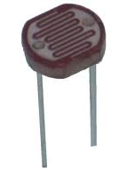
- Construct the same circuit that you used in Part I with the resistor replaced by the photoresistor, which looks something like this:

Set the voltage on the PS and measure and record the current. The exact values are not important as long as it is an easily measurable current, say a few mA.

- I = _______________________

- Vary the light level by alternately exposing the circuit to the room light and then covering it with, for example, a cap. Keeping the voltage constant, compare the current in light and dark situations.

- As the light on the photoresistor increases, does the current go up or down? _____________________
- Does this mean the resistance goes up or down? _______________________

    - Thermistor
- Now replace the photoresistor with the thermistor, which looks like this. You may have a capacitor in your kit, which looks very similar. The thermistor is darker brown and fatter, the capacitor is lighter tan and flatter. Ask if you are not sure which is which. Vary the temperature by carefully touching the device or blowing on it. If a heat gun is available, you can slightly heat the device with it, but be careful not to get it too hot. Keeping the voltage constant, compare the current as the temperature varies.

- As the temperature of the thermistor increases, does the current go up or down? __________________
- Does this mean the resistance goes up or down? _______________________

- (Later) Discussion of results and reflection:

- What kind of application can you envision for these two sensors?

- Do you have any further observations or comments on this part of the lab? Please reflect on your learning experience – what helped your learning and what detracted from it.

- Part III. Series and parallel circuits
  - Objective:
To observe the effects of resistors (and light bulbs) connected in series and in parallel.
  - Equipment:
Same as Part I plus at least 2 mini-light bulbs (these are the clear bulbs, not the red LEDs)
  - Background:
- Resistors in series have the same current going through them.
The equivalent resistance is R_{eqs} = R₁ + R₂ + …
Resistors in parallel have the same voltage across them.
The equivalent resistance is $R_{eqp}=\frac{1}{\frac{1}{R_{1}}+\frac{1}{R_{2}}+⋯}$
R_{eqp} for two resistors in parallel is $R_{eqp}=\frac{R_{1}R_{2}}{R_{1}+R_{2}}$

  - Lab assignments
    - Series connection
- We will first use light bulbs to give a visual impression of series and parallel circuits. Connect a single bulb to the power supply. Set the voltage around 1 to 2 V and observe the brightness while varying the voltage. The bulb should behave like a resistor with the brightness indicating current.

- Connect two bulbs of the same type in series. Observe the brightness, and how it compares to a single bulb with the same PS voltage. You can try it with three bulbs in series if you like for a stronger effect. Note: you should see a difference. If they look the same, look a little more closely, check your set-up, or ask for help.

- Are bulbs in series brighter, dimmer or the same compared to a single bulb? __________________
- Is the resistance of bulbs in series more, less or the same compared to a single bulb? ________________
- Do you think more, less or the same current is flowing through bulbs in series compared to a single bulb? _______________

    - Parallel connection
- Connect two bulbs of the same type in parallel. Observe the brightness, and how it compares to a single bulb and to the bulbs in series. Try it with three bulbs in parallel if you like for a stronger effect.

- Are bulbs in parallel brighter, dimmer or the same compared to a single bulb? __________________
- Is the resistance of bulbs in parallel more, less or the same compared to a single bulb? ______________
- Do you think more, less or the same current is flowing through each bulb in parallel compared to a single bulb? ___________
- Is more, less or the same current being drawn from the PS? ____________

- Replace the bulbs with resistors of approximately the same value, e.g., two 1 kOhm resistors. With a fixed voltage, measure the current with one resistor and then with two resistors in series. Also calculate the current from Ohm’s Law for the single resistor and for ReqS. List all values in the table below. For this part you can use the nominal 1 kOhm in your calculations to simplify the numbers. Be careful that you are making the current measurements correctly, as in Part I!

- Repeat step 4 with the two resistors in parallel. Measure the current coming out of the PS as shown in Figure 5.

Figure 5. Current measurement setup for parallel R-s.
- Fill in Table 4

Table 4. Resistance and currents for series and parallel connection of resistors.
Single R = Ohm | Reqs = Ohm | Reqp = Ohm
Single I_{calc} = mA | Series I_{calc} = mA | Parallel I_{calc} = mA
Single I_{meas} = mA | Series I_{meas} = mA | Parallel I_{meas} = mA

- (Later) Write a paragraph or two discussing the results and reflect on your observations:

- Explain in your own words reasons for what you observed when light bulbs were connected in series compared to a single bulb.

- Did the measurement with the resistors in series agree with what you observed with the bulbs?

- Did your measurement agree with the calculation?

- What are some reasons for any difference?

- Explain in your own words reasons for what you observed when light bulbs were connected in parallel compared to a single bulb.

- (Later) Referring to all three parts of the lab write a couple of short paragraphs discussing: (i) What did you learn overall in this lab? (ii) Please reflect on your learning experience – what helped your learning and what detracted from it.

